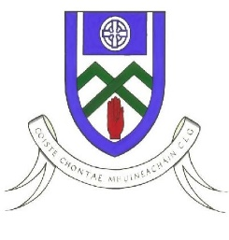
Cumann Luthchleas Gael
Coiste Chontae Mhuineachain
County Training Grounds, Cloghan, Annyalla, Castleblayney, Co. Monaghan
Paul O’Connor – 086 8374827 developmentmanager.monaghan@gaa.ie
Monaghan GAA Football After School Programme 2020

Re: Monaghan GAA Football After School Program

To Parent / Guardian,

Monaghan GAA Coaching & Games are delighted to confirm that we will be delivering our very successful After School Program in Gaelic Football.

For this coaching block we will be focusing on 6th class, BOYS ONLY. This is a Football Development Programme designed to improve player’s skills levels through small sided conditioned games.

The venue for the NORTH programme is St Macartans College Sports Hall. Each region will receive a 4 week coaching block.

Players Name ________________________________________

D.O.B _______/______/__________

School__________________________________________________

Club:

Parent/Guardian Name ______________________________________________

Parent/Guardian Contact Number ______________________________________

Please complete this part, take a photo and Whats App it to Eamon Hughes on 087 3528274

Dates Programme –Tuesday 16th,23rd,30th November & 7th December

Venue – St Macartans College Sports Hall.

Time – 4:15 to 5:30

What to bring – Jumper/Jacket & runners & boots and gumsheild. Bring your own water and your bottle must be labelled with your name.

Thanks Monaghan GAA Coaching & Games Staff

