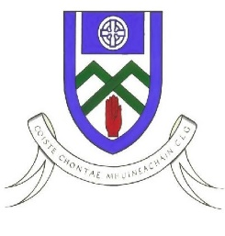
Cumann Luthchleas Gael
Coiste Chontae Mhuineachain
County Training Grounds, Cloghan, Annyalla, Castleblayney, Co. Monaghan
Paul O’Connor – 086 8374827 developmentmanager.monaghan@gaa.ie
Monaghan GAA Football After School Programme 2020

To Parent / Guardian,

Monaghan GAA Coaching & Games are delighted to confirm that we will be delivering our very successful After School Program in Gaelic Football.

For this coaching block we will be focusing on 6th class. BOYS ONLY. This is a Football Development Programme designed to improve player’s skills levels through small sided conditioned games.

The venue for the Mid programme is in Our Lady’s Secondary School Astro Turf Pitch. Each region will receive a 4 week coaching block.

Players Name ________________________________________

D.O.B _______/______/__________

School
________________________________________________

Club

Parent/Guardian Name ______________________________________________

Parent/Guardian Contact Number ______________________________________

Please complete this part, take a photo and Whats App it to Cormac Duffy on 087 7993216

Dates Programme – Tuesday 16th,23rd,30th November & 7th Decemebr

Venue – Our Lady’s Secondary School Astro Turf

Time – 4:15pm – 5:30pm

What to bring – Own water bottle (Well labeled) , Sanitizer, Water proof bag, Runners, Change of clothes

Thanks Monaghan Coaching & Games Staff

