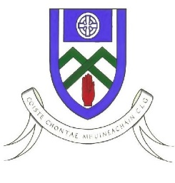
Cumann Luthchleas Gael
Coiste Chontae Mhuineachain
County Training Grounds, Cloghan, Annyalla, Castleblayney, Co. Monaghan
Paul O’Connor – 086 8374827 developmentmanager.monaghan@gaa.ie
Monaghan GAA Football After School Programme 2020

Re: Monaghan Football After School Program

To Parent / Guardian,

Monaghan GAA Coaching & Games are delighted to confirm that we will be delivering our very successful After School Program in Gaelic Football.
For this coaching block we will be focusing on 5th class BOYS ONLY. This is a Football Development Programme designed to improve player’s skill levels through small sided conditioned games.

The venue for the WEST programme is Largy College in the outdoor GAA pitch. This will be a 4 week coaching block (See dates below).

Players Name ________________________________________

D.O.B _______/______/__________

School__________________________________________________

Parent/Guardian Name ______________________________________________

Parent/Guardian Contact Number ______________________________________

Please complete this part, take a photo and whats app it to Ann McKenna on 0877580150

Dates Programme – Thursday 30th September & 7th/14th/21st October

Venue – Largy College GAA Pitch

Time – 4;15pm – 5.30pm

What to bring – Boots/Runners, Gumsheild, Waterbottle (Labeled with name),T-shirt, Jumper & Wet Jacket.

Thanks Monaghan Coaching & Games Staff

