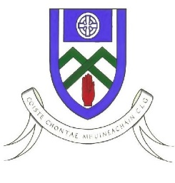
Cumann Luthchleas Gael
Coiste Chontae Mhuineachain
County Training Grounds, Cloghan, Annyalla, Castleblayney, Co. Monaghan
Paul O’Connor – 086 8374827 developmentmanager.monaghan@gaa.ie
Monaghan GAA Football After School Programme 2020

Re: Monaghan Football After School Program

To Parent / Guardian,

Monaghan GAA Coaching & Games are delighted to confirm that we will be delivering our very successful After School Program in Gaelic Football.
For this coaching block we will be focusing on 5th class BOYS ONLY. This is a Football Development Programme designed to improve player’s skill levels through small sided conditioned games.

The venue for the South programme is Pheonix Centre Carrickmacross in the outdoor Astro Turf. There will be a cost on hiring out the facility, so the cost will be €15 per player. This to be paid on the first day of the programme. This will be a 4 week coaching block (See dates below).

Players Name ________________________________________

D.O.B _______/______/__________

School__________________________________________________

Parent/Guardian Name ______________________________________________

Parent/Guardian Contact Number ______________________________________

Please complete this part, take a photo and whats app it to Cillian Cromwell on 087 9329614

Dates Programme – Wednesday 29th Sept & 6th, 13th & 20th October

Venue – Pheonix Centre Astro Turf

Time – 3:45pm – 5.15pm Cost - €15 (€3.75 per session)

What to bring – Astroturf Boots/Runners, Gumsheild, Waterbottle (Labeled with name),T-shirt, Jumper & Jacket.

Thanks Monaghan Coaching & Games Staff

