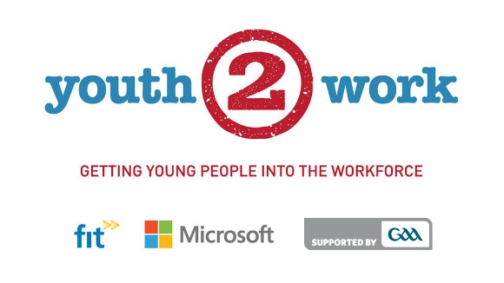

- Getting Young People into Jobs
  - Profiling Opportunities to Live & Work Locally
- HighlightingSkills Favoured by Employers
  - Information on Local Training Opportunities
- Career Advice, Mentoring and Placement Supports
  - Information on new jobs in emerging technologies
- Supporting Sustainable Communities
  - Ensuring job opportunities are accessible to young people locally
- Stimulating growth & expansion locally
  - Promoting confidence in communities and vibrancy in local sport

Y2W Careers Expo

Youth2Work (Y2W) will host 3Y2W Careers Exposin collaboration with CMETB acrossMonaghan in April / May 2016:

- Hillgrove Hotel, Monaghan Town. 25th April - 7.00 p.m.
- Nuremore Hotel, Carrickmacross. 9th May - 7.00 p.m.

Y2W Career Expos will be informative and fun, offering advice and hands-on advice support in securing quality employment locally.Information will be provided on the types of skills currently in demand with local employers, while current vacancies will be showcased and relevant courses available locally highlighted. Book you place at your preferred venue at Y2W@fit.ie

Y2W Overview

After much hardship including unprecedented youth unemployment, growthis once again taking pace in the Irish economy resulting in increasing opportunities for employment nationwide. Research indicates that growth is now beginning to spread out beyond urban centres breathing life into more towns and regions by the day. Monaghan and its hinterlandis now showing increased demands for skills right across the board from Manufacturing &Engineering, across Retail,Hospitality & Catering, to Tech and related sectors.

Once again local GAA clubs can look forward to growing their squads as new emerging job opportunities will enable job seekers to ‘work and play locally’. Capitalising upon these changing circumstances Microsoft, the GAA and FIT, together, plan to nurture healthy and sustainable communities by assisting young people to attain ‘in-demand’ skills to secure quality employment within the region.
Y2W is a highly innovative and dynamicInitiative through which the GAA in partnership with Microsoft and FIT want to help drive local awareness of the emerging job opportunities in tech and related sectors in the greater Monaghan region. Y2W seeks to ensure that new job opportunities are accessible to young people locally through appropriate training opportunities, career adviceand placement supports. The ultimate goal of Y2W is to enable young people get a quality job – ideally within their locality with local business.

In addition to creating awareness of the of range technology courses currently available locally through the support of CMETB, Y2W will provide hands-on career advice on the jobs that are available and will actively assist job seekers pursue their career ambitions and employment options. Y2W will also endeavour to drive awareness amongst small-to-medium enterprises, trading within Monaghan and its catchment area,of the role that new technologies can play in helping local businesses to grow, get online and expand.

By promoting smart skills favoured by employers amongst young people residing in local communities we hope that,over-time, employment will prosper in towns across the county. The objective is to connectthe graduates of Y2Wsupported skills development programmes with such employment opportunities- to help drive growth and expansion with the region.

At the planned Y2W Careers Exposparticipants will get information on the types of skills currently in demand with local employers. They will be able to apply for relevant courses provided by Cavan Monaghan Education and Training Board (CMETB) - quality programmes that pave the way to good jobs locally. Y2W will assist members of the GAA and the wider community commence and successfully complete the journey to quality employment with one-to-one mentoring and support.

Promoting Smart People with Smart Skills

TheY2W Career Exposwill highlight courseson offer across the county and in Cavan. The courses promoted and supported by Y2W will primary focus on equipping young people with employment skills in in-demand areas such as Business & Administration, Logistics & Warehousing, Retail, Tourism & Customers Care and tech skills in areas such as PC Maintenance; Social Media / Digital Marketing, Software Development, and Web Development.The Expos will alsobe of interest to the curious and the adventurous showcasing some of the latest tech trends and gaming technologies.

The Ambition

Y2W has the overall ambition to assist in excess of 10,000 young people nationally attain the skills that that are favoured by employers and as a consequence secure good jobs with great prospects. With an investment of €3m Microsoft, in collaboration with the GAA and FIT, wish to make a meaning and lasting contribution to youth employment thereby bringing prosperity, optimism and confidence to local communities and vibrancy to local sport.

Starting in Cavan andMonaghan, in time,the aim is to introduce Y2W to communities across Ireland.

If you are interested in further information, wish to support or participate in Y2W events contact FIT atY2W@fit.ie or review details at www.fit.ie

