COACHING ON THE GREEN
GAA INTERCULTURAL FUN DAY
THIS EVENT IS FREE
5 to 13 Yrs
COME ALONG AND HAVE A GO!
GAELIC FOOTBALL HURLING CAMOGIE ROUNDERS
Date: Sat 25th May
Venue: Ballybay Community College Football Pitch
Time: 1-3 pm

Entertainment will be provided throughout the Day & Refreshments Served

To Register contact:
Aurelia 042 9749500 / Ann 087 7580150

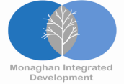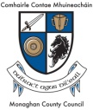
This project is part financed by the European Union’s European Regional Development fund through the PEACE III Programme funded through Monaghan PEACE III Partnership

