Insert
CLUB
CREST, here.
Name of CLUB

Responding to a
Critical Incident

Name of Club

Name of Club

Defining a critical incident:

The GAA, its clubs, counties, provide great support during and after all manner of incidents that may have traumatic or tragic consequences for members and their communities. This natural response by Clubs usually requires no external expertise or input. Nonetheless, it has been identified as an invaluable support to those involved. However, some situations can overwhelm even the most experienced and well prepared GAA officers and units. This critical incident plan is designed to offer some assurance about what steps to take in such situations.

‘A critical incident is any event that is outside the range of usual human experience. It is an event that causes an unusually intense stress reaction which has the emotional power to overwhelm an individual’s usual ability to cope. It may impede people’s coping mechanisms immediately or in the future following the event.

As a GAA Club, we have developed this ‘Response to a Critical Incident’ plan with a view to having a co-ordinated appropriate response, should the need arise and the plan will be implemented (when required), reviewed and updated after such an incident or annually at our club’s AGM.

Examples of critical incidents may include:

- Death or serious injury on or off the playing field
- Exposure to the aftermath of a road traffic accident e.g. the accident scene, the victim(s)
- Personal loss or injury, real or threatened to a child or adult
- Being violently threatened
- Close encounter with death
- Suicide of a club member (this tragic situation can cause extreme distress and confusion for everyone involved. Guidelines developed by professional services highlighting the most appropriate responses following a death by suicide by sporting organisations are available. Some of this information has been included in a special section on suicide in the Appendix section of this resource.)
- A situation with excessive media interest, a natural disaster or act of God
- Other incidents not covered above but which are associated with unusually strong emotional reactions

Sometimes a ‘critical incident’ – one that overwhelms one’s natural capacity to respond – will arise leaving individuals or communities struggling to cope. GAA clubs and counties have proven themselves invaluable in supporting their members’ and communities in responding to an array of tragic and seemingly insurmountable situations.
However, sometimes our club needs support in responding to critical situations too.
CLUB NAME G.F.C. have implemented the recommended ‘five step plan’ (outlined hereunder at page 4) and has developed key roles and duties for identified individuals (listed on page 6)

Name of Club

It is important to follow these 5 Key Principles during any critical incident.

*Key Point – Always consult with those affected to see what level of support they want / need.

- Promote a sense of safety
- Promote a sense of calm
- Promote a sense of self-efficacy and collective efficacy (i.e. the capacity to deal with the situation)
- Promote connectedness
- Promote hope
Recommended / Possible avenues for communicating a critical incident.

Incident reported to County Chairperson |  | County chairperson informs Health & Wellbeing chairperson |  | Health & Wellbeing chairperson informs Ulster Council Health & Wellbeing manager and Croke Park
Our role in responding to a critical incident
It’s important to remember that the GAA will usually be just one entity playing a part in any response to a critical incident. Figure 1 outlines some of the other entities that may be involved in a community response. It also highlights the importance of having the affected family or families at the centre of any plan while being consulted on all actions. Other ‘at risk’ persons will be to the forefront of considerations too.
Figure 1.
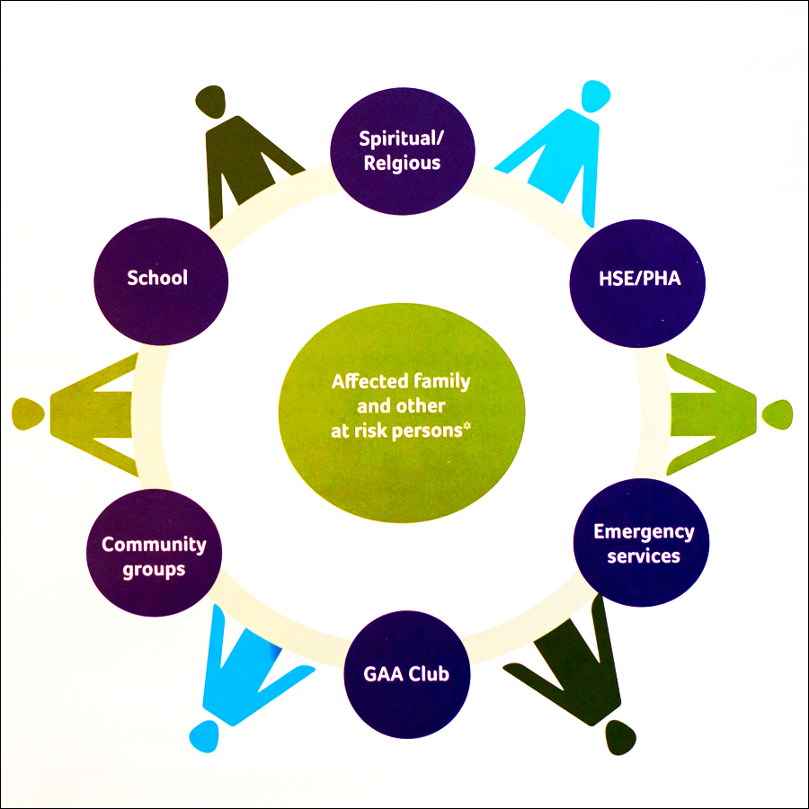
Figure 1: Some potential participants involved in a community based response to a critical incident.

Name of Club

Who Requires Support ?

In addition to the individuals directly affected, other ‘at risk’ persons are amongst those most likely to suffer distress as a consequence of an incident. Evidence would suggests that these may include those who:
- directly witnessed death/injury/violence as part of the incident
- are uninjured, but were at greatest risk
- are siblings of those immediately affected
- may blame themselves and/or those who may be blamed by others
- are experiencing instability at home
- have learning difficulties
- have pre-existing emotional and behavioural/mental health difficulties
- are vulnerable due to cultural and/or language difficulties
- have previously suffered bereavement or loss

It is important that these individuals should be considered in relation to specific needs.

By playing a part in the Response to a Critical Incident (figure 1) continuum of care cycle a local GAA club can help:
- Minimise the impact of the incident by supporting an appropriate, timely and flexible response
- Provide accurate information about the current situation to those affected and other stakeholders involved in the response
- Respond to the phased need of those affected including reassurance about normal responses to abnormal events, grief, or trauma
- Strengthen the sense of unity and the efficacy of the community response
- Offer signposting to more appropriate services as defined by need
- Support the immediate needs of the family or next of kin

Where to find support?

During a critical incident it is important to source help and support as quickly as possible for yourself or for anyone the club might be concerned about. If you are seriously concerned about someone, please contact 999/112 or the GP out of hours, North East Doc on Call – 1850 777 911

Samaritans (Official mental health partner & support helpline of the GAA)
Free helpline: Samaritans is a free helpline available 24 hours a day, 7 days a week for anyone struggling to cope.
116 123 in the Republic of Ireland
Email - jo@samaritans.org
Visit www.samaritans.ie for details of the nearest branch.

Contact details within your local community are indicated on page 7 of this document.

Name of Club

IN THE EVENT OF THIS CLUB HAVING TO
RESPOND TO A CRITICAL INCIDENT:
*****************************

It is vital that the Executive Committee of the Club and the Club’s Healthy Officer meet to discuss the appropriate response and set out clearly about implementing the PLAN.

Name of Club

Critical Incident Response Plan Name of Club G.F.C.

Designated liaison person and support team to oversee the plan –

Title | Name | Contact No
Club Chairperson
Healthy Club Officer
Club Public Relations Officer
Club Secretary
Alternative Person
Club Rooms Key holder

* People named on the plan with responsibilities should give 24 hour contact information.

Duties in Response to a Critical Incident:

Chairperson:
- Lead Person
- Garda / PSNI Contact / Report Incident to County Chairperson / Keep PRO up to date.
- Liaise with those directly affected – consider appointing a family liaison club member
- Organise and chair a debriefing for club members or specific groups

Healthy Club Officer:
- Liaise with local community and outside agencies and services, if required
- Identify relevant resources and services available at the club
- Review the Plan, after an incident / annual AGM

Public Relations Officer:
- Handle all media contact and liaise with the club chairperson throughout the incident

Secretary:
- Monitor the club’s response throughout the process
- Liaise with Chairperson , Healthy Club Officer and PRO and record the details of the club’s response

Name of Club

Useful GAA Contacts:

Title | Name | Contact No
Club Chairperson
Club Secretary
Club Public Relations Officer
Healthy Club Officer
Club’s Children Officer
County Health & Wellbeing Chairperson/committee member/s
County Chairperson
County Children’s Officer
County Public Relations Officer
National Children’s Officer
Croke Park
Community & Health Manager
Croke Park

Name of Club

Useful Local Community Contacts:

Title | Name | Contact No
Accident & Emergency
GP / Family Doctor
North East Doctor on Call
Defibrillator Contact Person/s
Gardai
Health Centre
Bereavement Support Services
Mental Health Services
Religious
School Principal
Social Services
Suicide Resource Officer/
Suicide Prevention Officer
Community First Responder
Citizens Information Centre
Youth Services

Name of Club

Checklist for reviewing the critical incident response plan

Have key roles been clearly identified and tasks clearly outlined?
Are personnel suitable?
Has contact been made to external agencies?
Is the contact list appropriate and complete?
Are materials such as press releases, letters readily available, for adaption to suit the particular circumstances?
Are telephone numbers on contact lists up-to-date?
Has a date been set for a review of the plan?
Where will the plan be kept and are people aware of this?

A Task for Healthy Club Officer or Club Childrens Officer :
Identify if there are other clubs / organisations that the person was closely involved with, where it may be important to make contact.
Also identify if possible, where there may be individuals from other clubs who may be particularly impacted upon by this event and contact those clubs also.

Name of Club

Appendix 1

Good practice guidelines following the death by suicide of a club member:

The death by suicide of a member of a club can have a deep impact on club members, in particular on teammates and coaches.
- How a club responds to a death by suicide depends on a number of factors including:
- How well known the person who died was to club members;
- How the club has dealt with past tragedies;
- The leadership shown by key club members; and
- Media coverage of the event.

What to do after a suicide:

Do’s

Acknowledge the death
Acknowledge that a club member has died. Respect that some families may choose not to describe the death as a suicide.

Acknowledge a wide range of feelings
Acknowledge that individuals will experience a wide range of feelings and emotions as a result of the death.
- Be gentle with each other – we all grieve in different ways
- The grieving process takes months and years, not days and weeks
- Don’t blame yourself or anyone else for the death

Try to get the balance right
Try to get the balance right between continuing to do normal activities (for example, following the funeral, go ahead with scheduled matches), but also make allowances that motivation and morale may be low among the team.

Try not under estimate young people’s natural ability to cope with difficult situations.

Keep an eye out for vulnerable people
Watch out for those who are not doing well or may be at greatest risk, for example:
- Brother and sisters of the deceased person who are also club members;
- Close friends;
- Teammates; and Others who may be experiencing difficult life situations at the time.

Anyone who may be particularly vulnerable at this particular time may need extra support. Having access to local support service’s contact details is important. You can usually call on these organisations for advice.
For more information on local support you, contact the local GP.

Anticipate sensitive dates on the calendar
Anticipate birthdays, holidays, anniversary dates and other celebratory events where the person’s absence from the team will be most felt. Accept that there will be times, such as these, when members of the club may benefit from extra support.

Name of Club
Don’ts

Don’t focus only on the positive
Do not remember the person who died by only talking about the positive things about them. While it is important to celebrate their sporting achievements and other personal qualities, it is also crucial to talk about the loss. Openly acknowledge and discuss the pain, and heartache, as well as any difficulties the person might have been experiencing, for example mental health issues, but with any discussions also encourage individuals to seek help if they feel the need to talk to someone.

Be careful how you pay respects
Do not do things in memory of the person like:
- Commemorative matches;
- Number on shirts; or
- Naming a trophy.

A Guard of Honour may be organised for other deaths. However, remember that a death by suicide differs from other deaths. Avoid any activities that glamorise or glorify suicide. The challenge is to grieve, remember and honour the deceased without unintentionally glorifying their death.

Do not over-indulge
Around the time of the funeral and immediately afterwards it is important to ask members and friends to try not to overindulge in alcohol, caffeine or other substances. They may make people more vulnerable at this time.

Helpful short and medium to long-term responses

After a death by suicide, clubs have found the following short-term and medium to long-term responses helpful.

Short-term
Right after a suicide those affected often look for the following:

Information
Clubs have found it helpful to identify what supports are available locally to provide advice, support and care at this time. As a result, many communities have developed local support cards outlining services available in the area. In Northern Ireland ‘Z Cards’ are available for each Health and Social Care Trust area, providing information on local support services.

Support
The first gathering of the team after the funeral, for example, the first night back at training, may be a difficult time for everyone. Coaches have found it helpful to break the team up into small groups and allow some time to talk about their deceased team member.
Coaches or team leaders may wish to prepare for this by thinking through the types of issues that they think will be raised and how best to create a safe place to discuss these matters. Coaches or team leaders should seek the help of local support services if they feel necessary. Some coaches may not feel comfortable in preparing for such a gathering.
The following topics are usually addressed:
- How to support people who are grieving at this time;
- Looking after yourself during this traumatic time; and
- What to look out for, say and do if you are worried about someone else.

Name of Club

Medium to long-term

Policies
Clubs are encouraged to develop policies and procedures on suicide prevention as well as other broader areas such as drug and alcohol use.

Training
Clubs find it helpful to offer training and skills development to coaches and team leaders. It may be useful to initially look at some form of resilience programmes/training that will help coaches/ members. There is also the opportunity to look at putting in place suicide awareness training in the longer term.

Name of Club

Appendix 2:

Sample support letter for members

We are all in shock from the untimely death of
To lose a loved one like NAME, a dear friend and team mate is one of the most difficult life experiences you will have to face.
When the death is sudden and tragic, Family Name, family and friends must cope with the sadness of their loss plus all their additional heightened feelings like confusion, questioning of self, anger and coming to terms with his death.
Should you wish to speak to someone in confidence about how you feel or if you need help or guidance to come to terms with NAME death, please call:
Samaritans, official helpline of the GAA and available 24-7, on their free-phone number
116 123 in Republic of Ireland or 08457 90 90 90 in Northern Ireland. Or Lifeline is a Northern Ireland crisis response helpline service operating 24 hours a day, seven days a week. If you or someone you know is in distress or despair, call Lifeline on 0808 808 8000.
The above is a confidential service available to you and we encourage you to avail of it and call, if you need to talk to someone.
Equally, should you know of any of your friends or colleagues, who are struggling to come to
terms with NAME death please encourage them to call also, or talk to a loved one about their feelings.
We also ask you to keep an eye out for each other, not to be shy or embarrassed about asking for help and to talk to and support each other during what is a very difficult time for us all.
If there is anything we can do to help and support you please let us know. We will get through this tragic time together.

_______________________________Chairperson,

on behalf of the Name Club Committee.

Phone: (insert your number here if you feel it is appropriate for any additional enquiries)

Name of Club

Appendix 3:

Guidelines for dealing with the media following a critical incident

Following a critical incident in which people have died, press interest in survivors and bereaved families can be intense. There are rules and standards that the press should follow. All members of the press have a duty to maintain the highest professional standards. The Independent Press Standards Organisation (IPSO) is charged with enforcing the ‘Editors’ Code of Practice’.
Individuals are under no obligation to speak to the media. If someone doesn’t want to speak to them - tell them.
When speaking with the media the following are some helpful tips:
- always make a note of the journalist’s name and contact phone number and role / publication at the outset
- consider appointing a club member as a family liaison person -
- don’t do anything in a hurry, whatever the journalist says about deadlines
- ask what they want to talk to you about in advance
- ask them to write down the questions they want to ask you in advance
- give yourself time to think about what you want to say
- write down your answers
- ask the journalist to ring you back at a specified time
- ask if you can see what they wish to quote from you before it goes to press - they may not do this, but it will alert them to your concerns about what they are going to publish
- never say anything ‘off the record’ unless both you and the journalist have a shared understanding of what this means
- remember that a journalist is entitled to report anything you say, so don’t mistake them for counsellors or friends
- bring the conversation to a close if you are uncomfortable

Sometimes journalists will ask for a photograph of the deceased, the family may or may not want this and remember that no one is under any obligation to do so. If you do, ensure that you never give an original photograph away, only a copy of it.

Name of Club

Appendix 4:

Sample announcement to the media

Template:

My name is (Name) and I am the (Role within the club) of (Name) club. We learned this morning
of the death of (Name). This is a terrible tragedy for family, our club and our community. We are deeply saddened by these events. Our sympathy and thoughts are with (Name) family and friends.
(Name of person) was a member of (Name) club and will be greatly missed by all who knew him.
We have been in contact with his/her parents and they have requested that we all understand their need for privacy at this difficult time.
Offers of support have been pouring in and are greatly appreciated. Our club have implemented our Critical Incident Response Plan.
The club has been open to members, to support them and to offer them advice and guidance. We would ask you to respect our privacy at this time.

_____________________________Chairperson.
( )

Note:

This can be used as a template to be emailed, faxed or given to the media. It may help to decrease the number of media calls and callers to the club.

In some instances it is not appropriate to provide names or information that might identify individuals.

This announcement will need to be changed based upon confidentiality issues, the wishes of the affected family and the nature of the incident.
A record of contact details for the individ

uals outlined above should be recorded in your unit’s Critical Incident Response plan (See R–2 in t

he Appendix to view the sample template plan’s contact list.)

Name of Club

Appendix 5:

What a debriefing session is and involves
Debriefing:
Debriefing allows those involved with the incident to process the event and reflect on its impact. (Davis, 1992; Mitchell, 1986).
A debriefing session will have three main objectives.
- Allows members to take time out to speak freely about the incident,
- It helps restore a form of ‘normality’ to members/the club which has been involved in a critical incident.
- An opportunity to provide members/the club with information on additional support services if required.
A debriefing session may take the form of a meeting/gathering and can sometimes be useful to have an independent person not directly involved in the incident to facilitate discussions.
A debriefing session may look at the following issues:
- What actions/interventions did the club/members take? e.g. was club rooms opened to allow community to come together? Was there information/support services information provided to members/community?
- What worked well?
- What could have worked better?
- Next steps – Record learning
- Forward Planning - Anything that needs to be put in place?
- Does the critical incident plan need amended?
- Are there any gaps?

