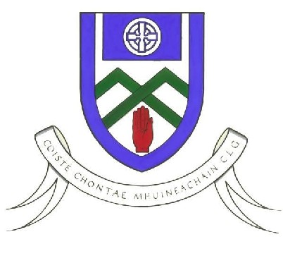
Cumann Luthchleas Gael
Coiste Chontae Mhuineachain
County Training Grounds, Cloghan, Annyalla, Castleblayney, Co. Monaghan
Monaghan GAA Football 6th Class North After School Programme 2019

To Parent / Guardian,

Monaghan GAA Coaching & Games realise the importance of player development and providing pathways for young players so that they can reach their full potential. For the past 8 years Monaghan Coaching staff organised an After School programme for players who are entering their last year in primary school. For this coaching block we will be focusing on 6th class. This is a Gaelic Skills Development Programme designed to improve those players who would like to take part in the programme.

The county has been divided into 4 regions (North, South, Mid & West). Each region will have a combination of large and smaller schools. The venue for the North programme is St Macartans College, Monaghan. Each region will receive a 4 week coaching block.

If your son is interested in participating in the North REGION programme which commences on Tuesday 15th January, please fill in the information below and get it back to me (see address below) before Friday 11th January. An e-mail will then be sent out to you to confirm your son is attending. The email will inform you of the day, time and venue of the programme.

This programme will cost €10 for the 4 weeks. Please bring on 1st day of programme. Your child will receive a training top on the last week.

This Coaching block will be led by Rory Beggan. They are fully qualified and Garda Vetted.

PLAYER | CLUB | SCHOOL | DOB | Parent/Guardian  Number | Parent/Guardian  Name

E-Mail Address
Training Top  Size | 9-11 12-13 S M

If you have any questions, please contact Rory Beggan as soon as possible. His contact details are listed below.

Yours in GAA,
Rory Beggan
Address: Entekra Centre of Excellence, Cloghan, Annyalla, Castleblayney, Co. Monaghan
Mobile; 087 3528274
Email; rory.beggan.gda.monaghan@gaa.ie

