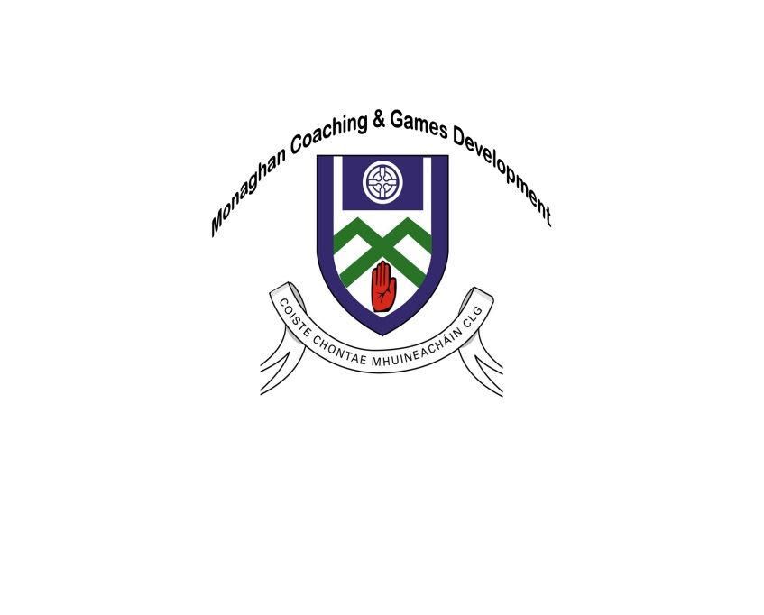
MONAGHAN GAA
Coaching & Games Development
Upcoming Coach Education Courses 2018/19

FOUNDATION AWARD
CODE | DATES | VENUE | TIME | COST
Football | 23rd / 24th November | TBC | Friday: 7pm – 10pm  Saturday: 9.30am – 4.30pm | €30 per person  Or 4 for the price of 3
Football | 18th/19th January | TBC
Football / Hurling | 8th/9th February | TBC
*Beginners Courses for all ages.
Coaches MUST complete the Child Protection Workshop on the Friday night in order to be certified. If you have previously completed Child Protection Training, you must bring the code number with you to the course.
Award Level 1
CODE | DATES | COURSE | VENUE | TIME | COST
Football | Fri 30th Nov & Sat 1st December | Youth / Adult | Monaghan GAA Training Grounds | Friday:  7pm -10pm  Saturday:  9am – 6pm | €55 per coach
Football | Fri 30th Nov & Sat 1st December | Child | Monaghan GAA Training Grounds
*All coaches must have the Foundation Award before completing the Level 1 Award. Each coach that attends the Award 1 Course will receive a copy of the ‘Give us a Game’ booklet.
If there is sufficient interest in running an Award 1 Hurling, we will arrange it.
Minimum 16 required for every course delivered, and payment MUST be made on the first night of the course
Closing Date: All places on the courses will close 7 days before the course commences.

Once a place on a course has been confirmed, the club/coach will be charged for that place even if they do not complete the course.

For information: Paul O’Connor 086 837 4827 / developmentmanager.monaghan@gaa.ie

