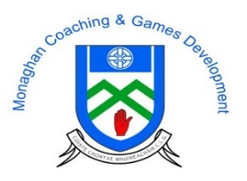
Go Games Referees 2017
Following on from feedback from the Go Games Review Meeting regarding the issue of Go Games Referee’s, the Monaghan Coaching and Games Committee are recruiting Go Games referees for the coming year.

All clubs are required to have at least 2 Go Games referees take part in the 2017 Programme.

- These referees will be offered €15 per blitz (each blitz lasts about 2 hours).
- All clubs are required to have at least 2 Go Games Referees for 2017.
- They will be required to referee at Under 8 and Under 10 blitzes. Overall there will be 9 under 8 blitzes and 9 under 10 blitzes (18 blitzes altogether).
- Blitzes will take place on a Saturday morning from 10am to 12 and Thursdays from 7pm-9pm.
- All candidates applying must be over 16 years of age.

There will be 2 steps to the recruitment process:
- The successful candidate’s will have to undertake 2 hours training (see date below), focusing on the playing rules of under 8 and under 10 Go Games.
- To follow on from this, the referees will officiate at the mini leagues during the Easter Camps. They will be assessed by the full-time staff on how they referee 2 games during the league. If successful they will go forward to referee at the County Go Games.

Dates for Referees Training:
- 2 hour theory & practical course on Go Games playing rules – Friday 14th April, 10am to 12pm (Easter Holidays)

Candidate Details;

Name: _____________________________________________

Address: ____________________________________________

Mobile Number: ______________________________________

Date of Birth: _________________________________________

Club: _______________________________________________

Details must be returned to Rory Beggan by Monday 10th April; post to Monaghan County Training Grounds, Cloghan, Annyalla, Co Monaghan, or email rory.beggan.gda.monaghan@gaa.ie

