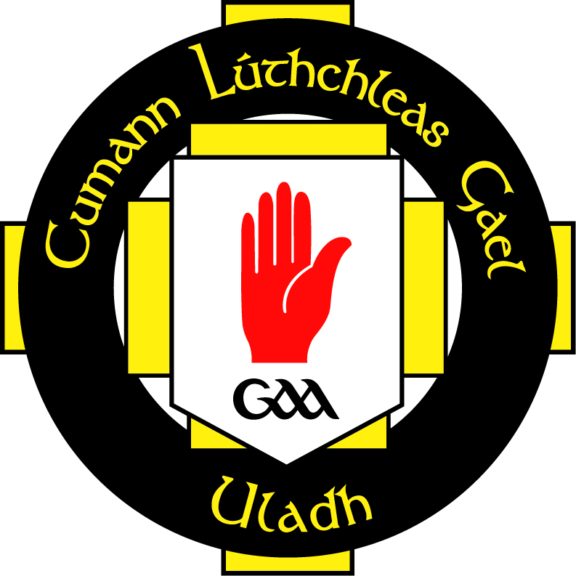
ULSTER GAA: Level 3 Diploma Courses
Introduction
The Ulster GAA in partnership with OCNNI will be running a Level 3 Diploma in GAA Sports Management commencing _____________.The objective is to reward the hard work undertaken by many volunteers in clubs, schools and county level and provide them with the opportunity to bring this into a formal qualification. In times of economic hardship and unemployment, the GAA Club environment can help people develop new skills and competencies that they can use when seeking employment.
Ulster GAA Team Management Programme
This programme is being delivered at the request of coaches who have made the transition from coach to manager. It recognises that coaching and managing have significant similarities but it also recognises that they are different. The series of workshops will take the coach/manager through a programme that will help explore the critical managerial areas to help develop understanding, competencies and abilities to apply critical thinking, problem solving and decision making skills.
This interactive programme is being delivered by GAA and Coaching Ireland Qualified Tutors and practicing managers and the subject areas will evolve around the following topics. This programme provides the basis to build further qualifications that are currently being delivered to volunteers. See table below:
Mandatory | GAA Sports Management | Credits (36 – 40)
Unit 1 | Making Plans and Decisions in Sports Contexts | 10
Unit 2 | Building Team Success | 10
Unit 3 | Managing Change and Conflict | 10
Unit 4 | Role of the Manager in the Sports Context | 10

It is envisaged that candidates applying for this course will need to have a minimum of Award 1 and be actively involved with their adult club, college or county team. For an application form contact roger.keenan.ulster@gaa.ie
Closing Date _________________ - Course Fees £125/€150
P.S. Each Unit is a stand-alone qualification and where coaches choose to complete one Unit or combination the cost with be £50 per Unit
Please contact Roger Keenan at roger.keenan.ulster@gaa.ie or Paul O Connor developmentmanager.monaghan@gaa.ie

