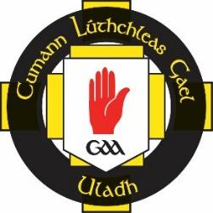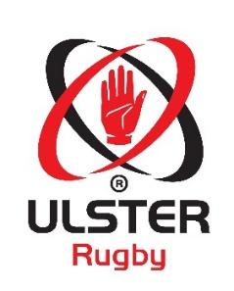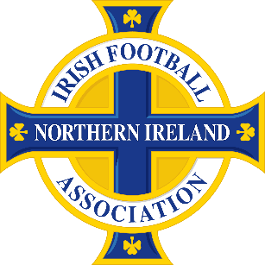

8th July 2016
Dear Club,

RE: PEACE IV DRAFT APPLICATION

Ulster Rugby, the Irish FA and Ulster GAA are conducting various joint consultation events on a Partnership funding application for European Peace IV money. The focus of our application will have a provincial reach (9 Counties of Ulster) with potential benefits for Clubs with regard to volunteering, club development, social inclusion and outreach. There will be a range of target groups, including females, young people, older people, ethnic minorities and those with learning disabilities.

We would like to invite you and/or your fellow Club representatives to attend one of the five consultation events taking place below. Details are as follows:

Date: Thursday 28th July
Time: 7pm - 9pm
Venue: Girdwood Community Hub

Date: Tuesday 2nd August
Time: 7pm – 9pm
Venue: The Waterfoot Hotel, Derry

Date: Thursday 4th August
Time: 7pm – 9pm
Venue: Brownlow Community Hub, Craigavon

Date: Tuesday 9th August
Time: 7pm – 9pm
Venue: Share Centre, Lisnaskea

Date: Thursday 11th August
Time: 7pm – 9pm
Venue: Newry Conferencing and Banqueting Centre

At these events we will present the first draft of our Peace IV application. You will have the opportunity to review the Plan and put forward your thoughts and views before a final submission is made.

Please contact Diarmaid Marsden at diarmaid.marsden.ulster@gaa.ie to confirm your attendance, making sure to outline the names of those attending and which event you would like to go to.

Yours sincerely,

Diarmaid Marsden
Head of Club and Community Development Department (Acting)
Ulster GAA

